**TASK 1**

**Objective:**

Write a C++ program that uses an inline function Circle Area to prompt the user for the radius of a circle and to calculate and print the area of the circle.

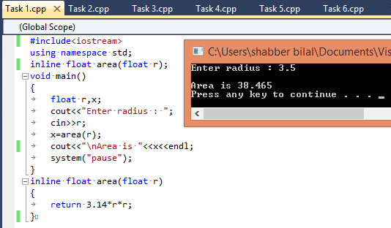

**TASK 2**

**Objective:**

Write a C++ program that uses an inline function “Convert” that converts the weight in pounds to kilogram.

One pound =0.4535 kg

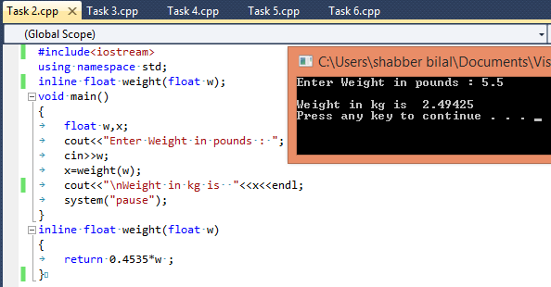

**TASK 3**

**Objective:**

Write a C++ that uses an inline function “Convert” that converts the temperature in Celsius to Fahrenheit.

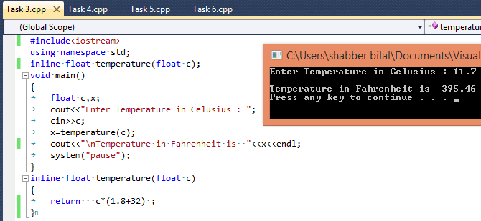

**TASK 4**

**Objective:**

Write a function that returns the average of 10 integers. In main you have to input an array of ten integers

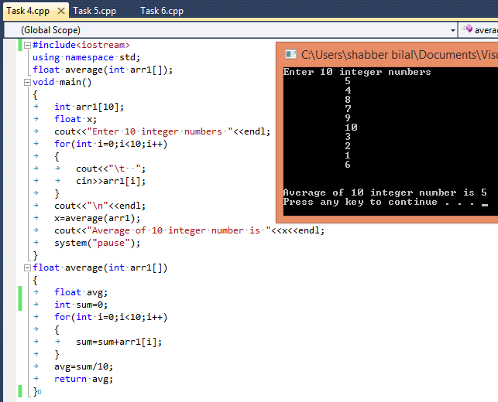

**TASK 5**

**Objective:**

Write a function that returns the smallest numbers. In main you have to input an array of ten integers.

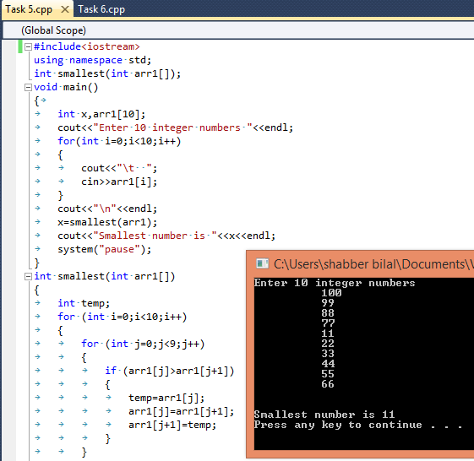

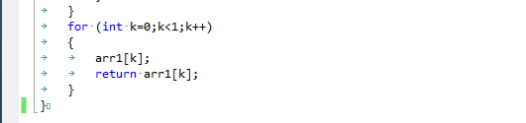

**TASK 6**

**Objective:**

Write a function that returns the largest alphabet. In main you have to input an array of ten capital letters.

